**Project Milestone 5**

* = tasks that need to be done as a group

***Part 2 due via email before 9am on Wednesday, 3/30;***

Parts 1, 3, due before class on Monday, 4/4; Part 4 due ASAP once GOMC gives AdWords  
access

Description  
In this milestone, each team will use search analytics to improve traffic to their website. Based  
on the results of their analyses, teams will make appropriate changes to their website where  
necessary. Specifically, the Milestone 5 submissions must include: Search Engine Optimization  
(SEO) (40%), Paid Search (50%), and Social Media (10%).

**Part 1: Search Engine Optimization (40%)**The two important aspects of SEO are content and linkage.  
**Part 1a: Content (25%)**

Sites:

|  |  |
| --- | --- |
| **Page** | **Keyword** |
| *Home - <https://www.eatnomz.com/> | EatNomz, Eat Nomz, Nomz, Asian Soups, Wholesome Asian Soups, Traditional Soup, Soup Delivery, Frozen Soup, Soup, Shitake Mushroom Soup, Beef Pho, Oxbone Soup |
| Collections/all - <https://www.eatnomz.com/collections/all> | Shiitake Mushroom Soup, Beef Pho, Oxbone Soup, Asian Soups, Wholesome Asian Soups, Traditional Soup, Soup, Noodle Soup, Asian Noodle Soup, Soup with Noodles, ji tang, xiang gu ji tang, pho bo, sul lun tang, PHỞ BÒ |
| Vietnamese beef pho - <https://www.eatnomz.com/collections/all/products/vietnamese-beef-pho-ph-bo> | Beef Pho, Vietnamese Beef Pho, Vietnamese Pho, Pho, Pho and Noodles, Pho and Rice, Pho Rice Noodle, Traditional Pho, Authentic Pho, Healthy Pho, Traditional Beef Pho, Authentic Beef Pho, Healthy Beef Pho, Traditional Vietnamese Pho, Authentic Vietnamese Pho, Healthy Vietnamese Pho, Pho Bo, Pho Delivery, Beef Pho Delivery, Vietnamese Pho Delivery, Vietnamese Beef Pho Delivery, PHỞ BÒ |
| Mushroom - <https://www.eatnomz.com/collections/all/products/chinese-chicken-soup-xiang-gu-ji-tang> | Shiitake Mushroom Soup, Chinese Shiitake Mushroom Soup, Chinese Soup, Chinese Chicken Soup, Chicken Soup, Chicken Shiitake Mushroom Soup, Chinese Chicken Shiitake Mushroom Soup, Chinese Noodle Soup, Chinese Chicken Noodle Soup, Xiang Gu Ji Tang, Ji Tang, red dates soup, goji berries soup, goji berries, goji berry, chinese noodles soup, chinese soup noodles, chinese chicken noodles soup, chicken noodles soup, chicken soup with noodles, chicken soup noodles, shiitake mushroom Traditional Chinese Shiitake Mushroom Soup, Authentic Chinese Shiitake Mushroom Soup, Healthy Chinese Shiitake Mushroom Soup, Traditional Chinese Shiitake Chicken Soup, Authentic Chinese Chicken Soup, Healthy Chinese Chicken Soup, Traditional Chinese Chicken Soup, Authentic Chinese Shiitake Chicken Soup, chinese chicken soup delivery, chicken soup delivery, ji tang delivery, xiang gu ji tang delivery, xianggu ji tang, xiang gu jitang |
| *KOS - <https://www.eatnomz.com/collections/all/products/korean-oxtail-soup-sul-lun-tang> | Korean Oxbone Soup, Oxbone Soup, Korean Soup, Oxbone, Oxbone Soup and Noodle, Korean Oxbone Soup and Noodle, Korean Oxbone Soup and Rice, Oxbone Soup Noodle, Traditional Oxbone Soup, Authentic Oxbone Soup, Healthy Oxbone Soup, Traditional Korean Oxbone Soup, Authentic Korean Oxbone Soup, Healthy Korean Oxbone Soup, Traditional Korean Soup, Authentic Korean Soup, Healthy Korean Soup, Sul Lun Tang, Oxbone Soup Delivery, Sul Lun Tang Delivery, Korean Oxbone Soup Delivery |

Separate analysis:

Purpose is to learn how other websites structure their “about us” pages

Keywords: about us, our story, our history,

About Us - <https://www.eatnomz.com/pages/about-us-1>

Blog - <https://www.eatnomz.com/blogs/news>

**********************

Use this to simulate New York Search. Location = ‘New York County’ (i think)

<https://serps.com/tools/google_search_location>

1. Use Google Webmaster tools to analyze your home page and at least four other pages in  
your site (under Health Fetch as Google). The results are a good indicator of how  
search engines are viewing your website’s pages. Are things being viewed as intended?  
Include screenshots in your explanation. Do you think the content is sufficient for search  
engines to adequately index these pages? (Jairus)

Partial vs Complete Source: <https://productforums.google.com/forum/#!msg/webmasters/3X0X8c3c39U/VXFOwHxZ4KUJ>

2. For each of the 5 pages analyzed in #1 (i.e., to be repeated five times):  
o Make a list of at least 10 common keywords users are likely to use to search for  
content related to that page (referred to here as the target page).  
o Also identify 10 competing pages based on search engine results and domain  
knowledge.  
o Use RapidMiner to extract the TFIDF values for the keywords from the target  
page as well as the 10 competing pages.  
o How well does the target page compare to the competing pages with respect to  
TFIDF values for these keywords?

**Please see the appendix for before and after TFIDF matrices.**

*3. Make changes to your website based on the analysis performed in #2, as needed. Be sure  
to include a before/after table for each target page, showing improvements in TFIDF  
values. Be sure to balance SEO with DUX and to avoid keyword stuffing!

4. In her talk on SEO, Janet Driscoll Miller mentioned several additional steps that can be  
taken to improve search engine visibility:  
o Rich snippets (see Google Webmaster Tools Optimization Structured Data)   
2  
o Meta and Title tags (see Google Webmaster Tools Optimization HTML  
improvements)  
o Data Highlighter (see Google Webmaster Tools Optimization Other resources)  
Apply these and/or other SEO improving steps. Be sure to describe what actions were  
performed. Note: if you’re client’s website is WordPress-based, the Yoast SEO plugin  
might be helpful for some of these tasks.

**Part 1b: Linkage (15%)**

1. Use the online Page Rank checker (http://www.prchecker.info) to attain the Page Rank  
for your home page and 2-3 additional pages. Home page scores of 3-4 or higher are  
considered good for small business/non-profit websites. Lower scores can be  
problematic. The higher, the better. Report the results in a table.

(Page Rank N/A. Page should be indexed, maybe not indexed correctly for long enough for a page rank to show)

NA -- the site has not been indexed yet or not been indexed for long enough to receive a rank

2. Use Google Webmaster tools to examine the present in-links for your website. Download  
the in-links table as a CSV file. Which in-links appear to be contributing the most to your  
home page’s Page Rank? (In links N/A… ???)

NA - Don’t have the site set up properly in the search consol**e**

*3. Identify at least 5 additional websites, blogs, social media sources, and/or forums that  
could serve as good potential outlets to place links pointing towards your website.  
Examples include Google+ page, Yelp, TripAdvisor, Facebook Fan Page, etc.

Google+

Facebook

*4. For the pages identified in #3, create in-links for your home page on as many as possible.  
Google + is absolutely essential for SEO! Note- some of these might need to verify your  
business via phone or mailed verification code (e.g., Google +). You’ll want to get this  
done before the GOMC to improve search visibility and rankings (organic and paid  
search).

5. Use Google Webmaster tools to see how many of the in-links created have been included  
in Google’s index.

*6. Identify and remove unnecessary out-links (if any) that are “leaking” PageRank to nonaffiliate  
external site’s pages. Important widgets (e.g., Google Maps) are generally not  
considered unnecessary out-links.

**Part 3: Social Media (10%)**  
There are now roughly 30 social networking websites with over 1 million members, each.

*1. Describe the client’s existing social media presence. Use the OneUpWeb scorecard  
mentioned in the SEO slides (slides 45-55 of the Paid Search deck). The PDF posted on  
Blackboard (under the Project folder) provides the complete scorecard. **(Scorecard = solo task)**

*2. If you and/or your client haven’t done so already, begin promoting your website on  
Facebook, Twitter, YouTube, and other relevant social media. Potential avenues include  
adding widgets to your site, posting comments, tweeting, creating a Facebook page,  
developing a YouTube channel, etc. Describe all additional efforts undertaken.

3. Present the revised scorecard (i.e., after your social media efforts).

\***Part 4: Adwords Setup (20%) – to be completed once GOMC gives you account access**  
For Part 2, you will need to *use the keyword research tools and Adwords to develop sample Ad  
Copy. You can use any Google AdWords account to do this (e.g., team Google account). Good  
to get a little practice in the AdWords environment. Just make sure not to actually run the ads!  
As part of Part 4, you will need to *fully develop your campaigns, ad groups, ad copy, and  
associated keywords. Use your GOMC-provided account to do this (i.e. once you’ve  
uploaded your pre-campaign report to GOMC via the Student Dashboard).

Milestone Evaluation Criteria  
For this milestone, each team will be evaluated based on its:  
• ability to effectively and thoroughly apply search analytics methodologies;  
• effectiveness in deriving interesting and important insights from the results;  
• writing quality: make sure that all tables and figures have appropriate captions (including  
sequential numbering).

**Appendix 1 TFIDF matrices**

**Home**

Before:

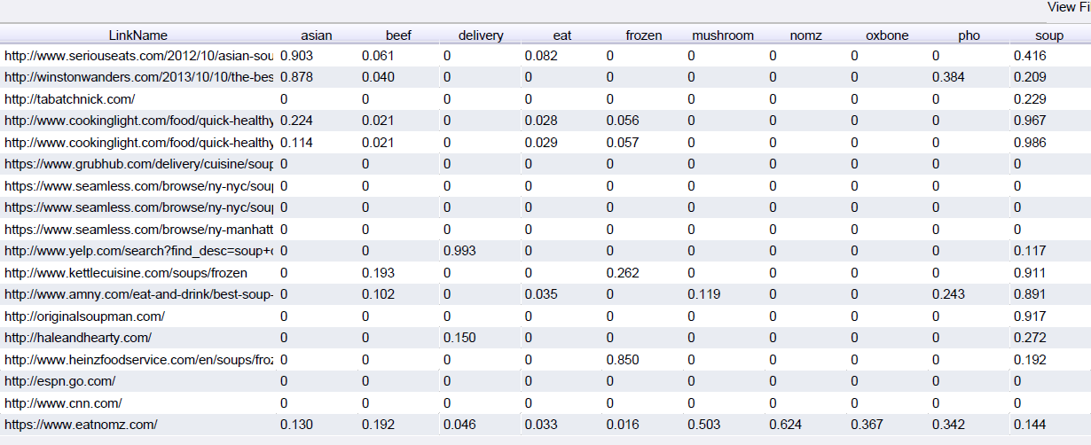

After:

**Collections/all**

Before:

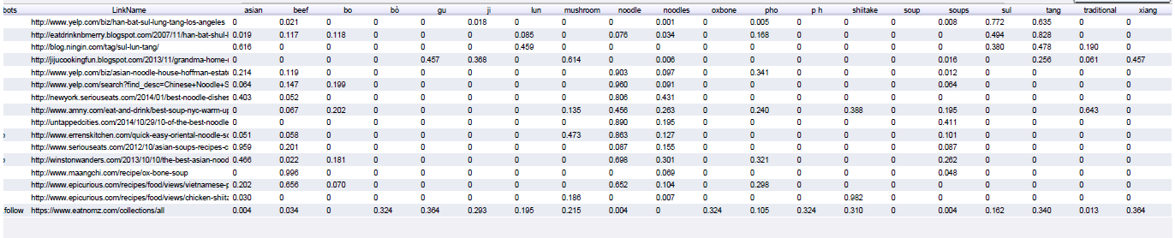

After:

**VBF**

Before:

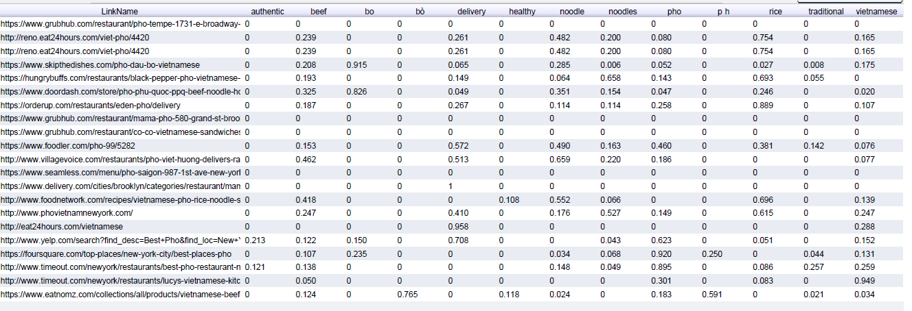

After:

**Mushroom**

Before:

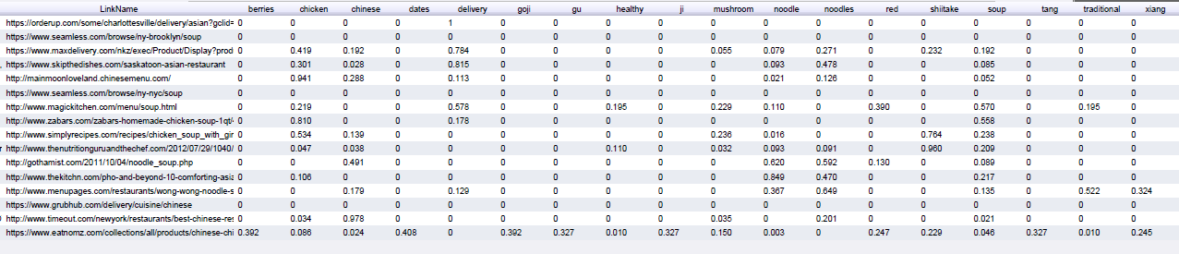

After:

**KOS**

Before:

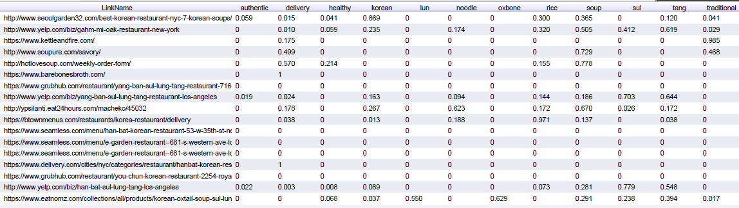

After: